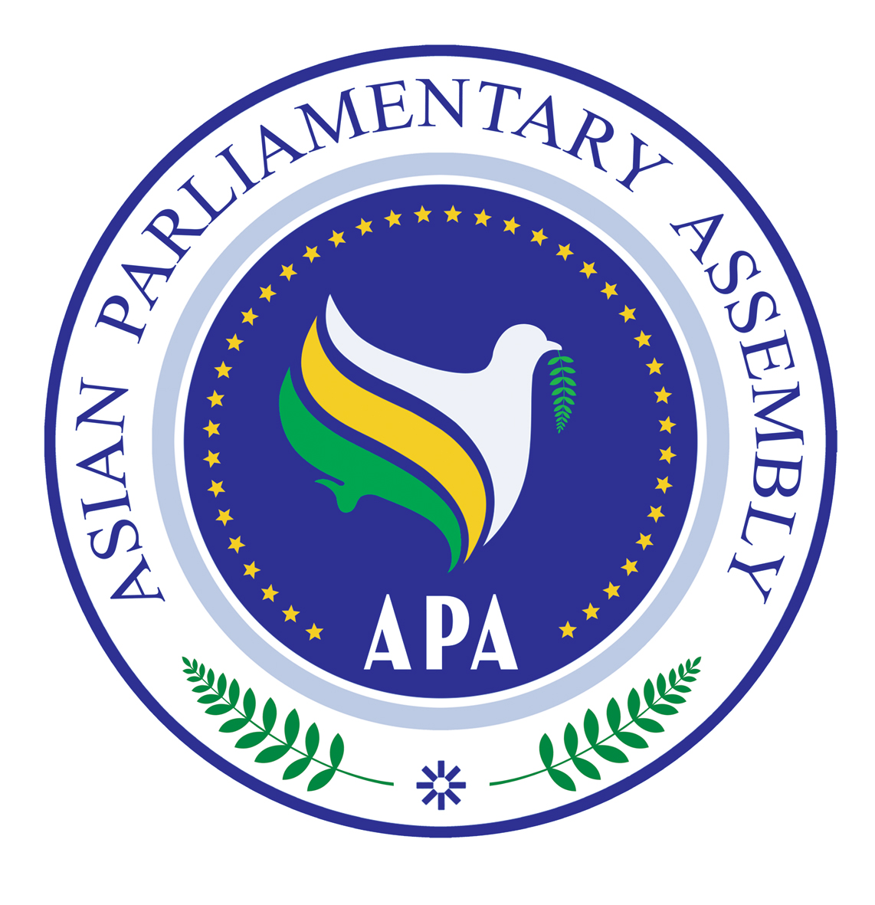
Asian Parliamentary Assembly
Standing Committee Meeting on Economic
and Sustainable Development

Pissouri - Cyprus
26 June 2018

Draft Agenda

- – Adoption of the Agenda
- – Election of the Bureau
- - Opening remarks by the Chairperson
- – Report/Remarks of the APA Secretary-General
- - Consideration and Recommendations on the Draft Resolutions:

- Draft Resolution on Asian Integrated Energy Market
- Draft Resolution on Environmental Issues
- Draft Resolution on Financial Affairs: Ensuring Efforts for Economic Growth
- Draft Resolution on Poverty Eradication
- Draft Resolution on Water and Sanitation in Asia for All
- Draft Resolution on The Role of APA Parliaments in Supporting the Implementation of the Sustainable Development Goals

- - Any Other Matters

